**Designing and Implementing a VLSM Addressing Scheme**

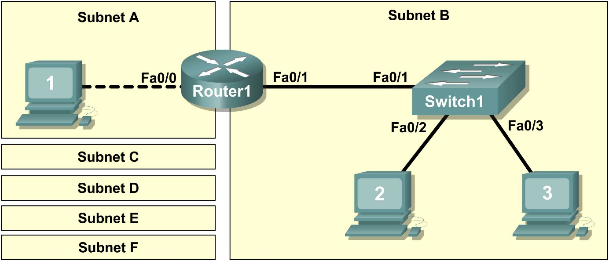

1. Scenario

In this lab, you will create a small network that requires connecting network devices and configuring host computers for basic network connectivity. SubnetA and SubnetB are subnets that are currently needed. SubnetC, SubnetD, SubnetE, and SubnetF are anticipated subnets, not yet connected to the network.

Task 1: Design the Logical Lab Topology.

Given an IP address and mask of **172.20.0.0 / 24** (address / mask), design an IP addressing scheme that satisfies the following requirements:

|  |  |
| --- | --- |
| **Subnet** | **Number of Hosts** |
| **SubnetA** | As shown in topology diagram |
| **SubnetB** | Between 80 – 100 |
| **SubnetC** | Between 40 – 52 |
| **SubnetD** | Between 20 – 29 |
| **SubnetE** | 12 |
| **SubnetF** | 5 |

Note: Always start with the subnet with the largest number of hosts and work your way down. Therefore, you should start with SubnetB and finish with SubnetA.

Design subnets address blocks

|  |  |  |  |  |  |  |
| --- | --- | --- | --- | --- | --- | --- |
| **Subnet**  **description** | **Number of hosts** | **Host bits** | **Subnet mask**  **( /Format )** | **Subnet mask**  **(Decimal notation)** | **Order** | **Subnet** |
| **SubnetA** | 2 | 2  2 a la 2 – 2 = 2 | **/30** | **255.255.255.252**  **255.255.255.1111 1100** | **6** | **172.20.0.248**  **172.20.0.252** |
| **SubnetB** | 80 -100 | 7  2 a la 7 – 2 = 126 | **/25** | **255.255.255.128**  **255.255.255.1000 0000** | **1** | **172.20.0.0**  **172.20.0.128** |
| **SubnetC** | 40 - 52 | 6  2 a la 6 – 2 = 62 | **/26** | **255.255.255.192**  **255.255.255. 1100 0000** | **2** | **172.20.0.128**  **172.20.0.192** |
| **SubnetD** | 20 - 29 | 5  2 a la 5 – 2 = 30 | **/27** | **255.255.255.224**  **255.255.255. 1110 0000** | **3** | **172.20.0.192**  **172.20.0.192+32**  **172.20.0.224** |
| **SubnetE** | 12 | 4  2 a la 4 – 2 = 14 | **/28** | **255.255.255.240**  **255.255.255. 1111 0000** | **4** | **172.20.0.224**  **172.20.0.224+16**  **172.20.0.240** |
| **SubnetF** | 5 | 3  2 a la 3 – 2 = 6 | **/29** | **255.255.255.248**  **255.255.255. 1111 1000** | **5** | **172.20.0.240**  **172.20.0.240+8**  **172.20.0.248** |

|  |  |  |  |  |
| --- | --- | --- | --- | --- |
| **Subnet**  **description** | **Subnet** | **First Host Address** | **Last Host Address** | **Broadcast** |
| **SubredB** | **172.20.0.0** | **172.20.0.1** | **172.20.0.126** | **172.20.0.127** |
| **SubnetC** | **172.20.0.128** | **172.20.0.129** | **172.20.0.190** | **172.20.0.191** |
| **SubnetD** | **172.20.0.192** | **172.20.0.193** | **172.20.0.222** | **172.20.0.223** |
| **SubnetE** | **172.20.0.224** | **172.20.0.225** | **172.20.0.238** | **172.20.0.239** |
| **SubnetF** | **172.20.0.240** | **172.20.0.241** | **172.20.0.246** | **172.20.0.247** |
| **SubnetA** | **172.20.0.248** | **172.20.0.249** | **172.20.0.250** | **172.20.0.251** |

Task 2: Configure the Logical Topology.

Document logical network settings.

* On **SubnetA**, **Host1** will use the **first IP address** in the subnet.
* **Router1**, interface **Fa0/0**, will use the **last host address**.
* On **SubnetB**, host computers will use **the first and second IP addresses** in the subnet, respectively.
* **Router1**, interface **Fa0/1**, will use the **last network host address**.
* **Switch 1**, interface **VLAN 1**, will use the **next-to-last host address.**

To properly route Layer 2 frames between LAN devices, Switch1 does not require Layer 3 configuration. The IP address assigned to Switch 1, interface VLAN 1, is used to establish Layer 3 connectivity between external devices and the switch.

Write down the IP address information for each device:

|  |  |  |  |  |
| --- | --- | --- | --- | --- |
| **Device** | **Subnet** | **IP Address** | **Mask** | **Gateway** |
| **Host1** | **172.20.0.248** | **172.20.0.249** | **255.255.255.252**  **/30** | **172.20.0.250** |
| **Router1-Fa0/0** | **172.20.0.248** | **172.20.0.250** | **255.255.255.252**  **/30** | **NA** |
| **Host2** | **172.20.0.0** | **172.20.0.1** | **255.255.255.128 /25** | **172.20.0.126** |
| **Host3** | **172.20.0.0** | **172.20.0.2** | **255.255.255.128 /25** | **172.20.0.126** |
| **Switch1** | **172.20.0.0** | **172.20.0.125** | **255.255.255.128 /25** | **172.20.0.126** |
| **Router1-Fa0/1** | **172.20.0.0** | **172.20.0.126** | **255.255.255.128 /25** | **NA** |

